CHILDREN OF THE SNOW LAND
In UK Cinemas and On Demand from 14 March 2019

“An incredibly inspiring story from the roof of the world.”
Bear Grylls

Dartmouth Films, Mayfly TV and Picture on the Wall Productions are proud to announce the release of CHILDREN OF THE SNOW LAND in UK cinemas and on demand with Curzon Home Cinema from Thursday 14 March 2019, with the UK gala premiere screening with Q&A taking place that evening at Curzon Soho.

CHILDREN OF THE SNOW LAND tells the incredible story of a group of children born in the High Himalayas of Nepal; a remote area of great natural beauty but where life is extremely tough. From just four years old, some children are sent by their parents to the capital city, Kathmandu, to a school run by a Buddhist monk, in the hope that education will give them a better chance in life.

For ten years or more they do not see or speak to their parents, due to the remoteness of their villages.

Upon graduation, aged 16, the children must make the journey home; an arduous trek across mountains that takes them to the highest inhabited place on the planet; a faraway, off-grid land where the way of life has not changed for thousands of years. The young children who left their parents many years ago will return to their villages as teenagers who have been brought up in a world of mobile phones, social media and most modern conveniences. And then the earthquake strikes.

Directed by Zara Balfour and Marcus Stephenson, and executive produced by Christopher Hird, CHILDREN OF THE SNOW LAND film documents the scary, moving, funny and humbling stories from the world’s longest walk home from school.

Partly filmed by the Nepali children featured in the film, CHILDREN OF THE SNOW LAND offers a view of a remote, ancient place, where the way of life has remained unchanged for the past 2,000 years and explores the human spirit’s extraordinary capacity to survive and thrive in difficult circumstances with meagre resources, whilst asking the universal question - what makes a family?

Children of the Snow Land is in UK cinemas & on demand
with Curzon Home Cinema from 14 March 2019

The UK gala premiere will take place at 6.30pm on Thursday 14 March at Curzon Soho, tickets available now at: bit.ly/snowlandsoho

To request screening dates, interviews and further assets contact:
Andy Green (Freelance): andy.green@waytoblue.com
Christelle Randall (Global Publicity Director): christelle.randall@waytoblue.com

Download trailer HERE / embed code HERE

Download key images HERE

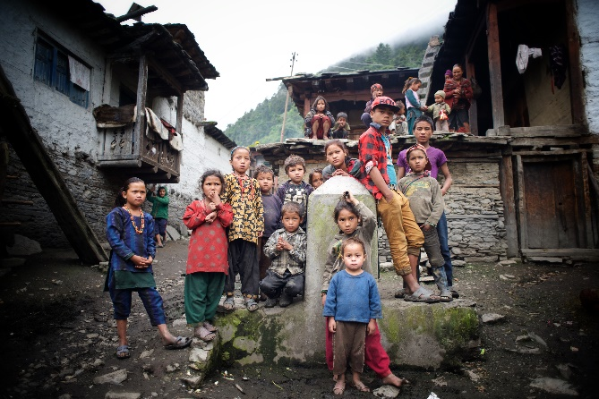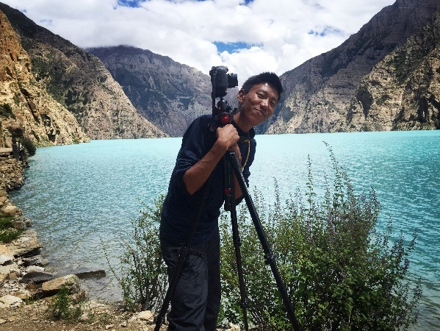

CELEBRITY SUPPORTERS
Bear Grylls "An incredibly inspiring story from the roof of the world."

Joanna Lumley “Imagine not seeing your parents and home for 12 years! This is a stunning film.”

Kate Humble “An extraordinary story, told with great sensitivity and skill. Both heartbreaking and
uplifting, this is a film full of insight and wonder. I urge you to see it.”

Levison Wood “A journey like this is no mean feat even for the most experienced trekkers.”

Sir Chris Bonington “Wonderful film."

Doug Scott CBE “Marvellous film. We should support every initiative to put schools into such remote
villages”.

#SnowLandFilm

ChildrenoftheSnowLand SnowLand_Film SnowLand_Film
www.childrenofthesnowland.com

